**LOWER, UPPER, CONCAT, TRIM**

**CANCAT**

Concat is not in postgres sql, in **IBM Db2** concat takes only two argument to concat the string, but in mysql it takes any no of argument.

**SYNTAX:**

Select ConCat(st1,str2, column_name1) From table_name;

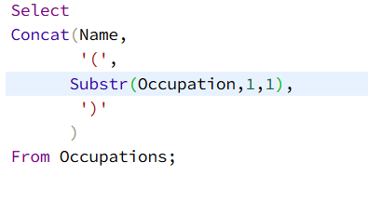

**TRIME:**

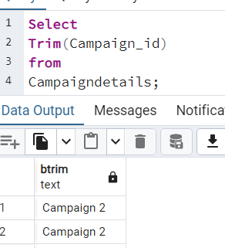

**LPAD:( No in postgres sql)**

Helps to add some extra chars to existing strings

**SYNTAX:** Lpad(column_name, no_of_time_to_add_new_chart, ‘new char’)

**Note:** no_of_time_to_add_new_char value should be greater than the current string length

Then only it able to add new char.

In below * is printed 15 times at the left of the each string.

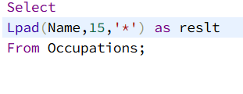

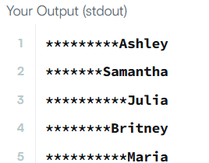

**RPAD –** Right pad

**REPLACE**

SYNTAX: Replace(column_name, “old char”, “new char”)

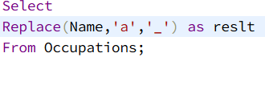

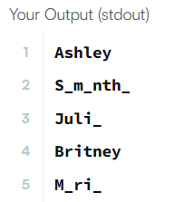

**INSTR (not in postgres sql)**

Helps to see the position of a specified char in a string. If the char is not fount it returns 0

**SYNTAX:** Instr(column_name,’char’)

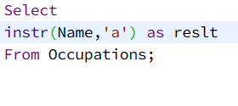

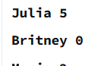

**RIGHT, LEFT**

Helps to extract chars from right and left position of the string

**Syntax:** Left(column_name, no_of_char_you_want)

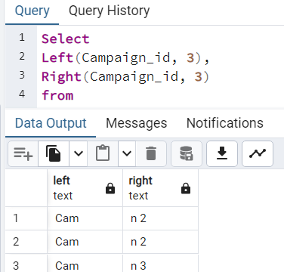

**REVERSE**

